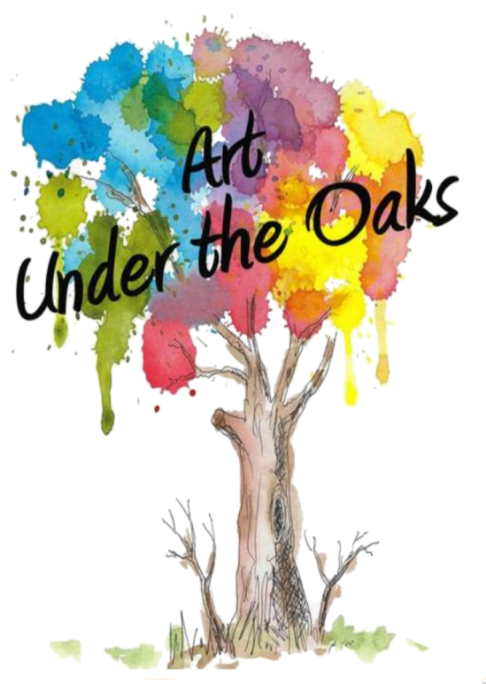
Five Civilized Tribes Museum
1101 Honor Heights Drive
Muskogee, Ok 74401

Art Under the Oaks
Competitive Art Show
April 4 - April 30, 2026

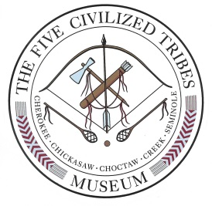

*******Important Dates ********

Friday, March 20, 2026 4:00PM Deadline for entries

Saturday, April 4, 2026 Reception and Awards Presentation
2:00 - 4:00 pm

Thursday, April 30, 2026 Exhibit ends (artists may pick up their work
starting May 1, 2026 - Mon.-Fri. 10-5, Sat. 10-2)

Saturday, May 16, 2026 Last day to pick up artwork

*******Information*******
ELIGIBILITY
- Artists must be 18 years of age or older. ENTRANTS MUST BE A CITIZEN OF AT LEAST ONE OF THE FIVE TRIBES (Cherokee, Chickasaw, Choctaw, Muscogee or Seminole) AND ARE REQUIRED TO ENCLOSE A COPY OF THEIR CDIB OR TRIBAL REGISTRATION CARD.
- Artwork must be less than 1 year old.
- Work must not have been previously entered in any show at the Five Civilized Tribes Museum.
- Entries must be ready to display. All hanging entries must be hung by wire; no saw tooth hangers will be accepted.
- Two dimensional entries may NOT exceed 48” X 48” (including frame).
- Sculptures must be able to fit in an area 36” X 36” X 72” tall.
- 2D Artwork categorized as miniatures must be framed (unless gallery wrapped with finished edges) with a total size not to exceed 8”X 10” and the art image may NOT exceed 4” X 4”. This category is only for paintings/graphics.
- 3D Artwork categorized as miniatures may not exceed 4” in length, width, or depth. Measurements exclude bases. Overall exterior may not exceed 8”x8”. This category includes: basketry, sculptures, pottery, and cultural items.
- ENTRIES CANNOT CONTAIN PARTS OF A PROTECTED SPECIES, SUCH AS, CLAWS, FEATHERS, BONES, FUR, ETC. ANY ENTRY WITH THE ABOVE MENTION ATTACHED, WILL BE IMMEDIATELY DISQUALIFIED UNDER FEDERAL LAW. UNDER OKLAHOMA LAW TITLE 29, STATUTES 5-411, 7-503; WILD ANIMAL FEATHERS OR PARTS (INCLUDING, BUT NOT LIMITED TO WILD TURKEY) ARE PROHIBITED UNLESS DOCUMENTATION (SUCH AS A RECEIPT) IS PROVIDED, PROVING THEY WERE PURCHASED THROUGH A COMMERCIAL RETAILER OR BREEDER.
- All pieces entered must be for sale.

NUMBER OF ENTRIES
Two entries per artist; a third piece may be entered in the Miniature division.

DEADLINE
Entries will not be accepted after Friday, March 21, 2025 – Entries must be received at the Museum before 4:00p.m.

CATEGORIES
- PAINTINGS
- Original works in watercolor, acrylic, gouache, oil or tempera.
- All paintings must be framed and ready to display. Stretched canvas with finished sides need not be framed, but must be ready to hang.
- GRAPHICS
- Original works in ink, pencil, pastels, scrimshaw, graphite, photography and digital creations.
- Work must be matted and framed.
- Photographs must be signed and numbered if in editions, and are not to exceed editions of 50.
- Giclee’ prints are NOT ALLOWED.
- SCULPTURE
- Hand–wrought materials such as stone, wood, metal, ceramic, paper, or cloth will be accepted.
- Un-fired clay will NOT be accepted.
- Cast resins are NOT ALLOWED.
- Fixatives can be used to stabilize pigment and must be disclosed.
- Bronze sculpture in numbered editions must be signed and numbered.
- POTTERY
- Traditional: Hand-built pottery. Clay and tempering materials should be collected, processed and traditionally fired by the artists. Traditional shapes and designs are preferred.
- Contemporary: Wheel–thrown pottery. Slip molds, green ware, or commercial potteries are NOT ALLOWED. Kiln-fired, commercial clays, commercial paint and glazes are permitted.
- CULTURAL ARTS
- This category is open to traditional crafts like masks, toys, stickball sticks, traditional weapons (knives, blow guns, bow and arrows, war clubs, points), and cooking utensils. (All wood pieces must be treated for insects.)
- Non-fired clay will not be accepted.
- BASKETRY
- Traditional: Items entered in this category must be created by the artist using traditional and native materials indigenous to the Five Civilized Tribes. Roots and fibers of plants and tress such as buck brush, honeysuckle, willow, pine needles, river cane and split woods are acceptable. Natural dyes are encouraged.
- Contemporary: Materials such as commercial reed and raffia are permitted. Commercial dyes are acceptable.

- TEXTILES
- Items include – weaving, blankets, tapestries, clothing, ribbon-work, quilts, ceremonial garments, applique’, shawls and sashes.
- Sewing machine work is acceptable.
- Commercially made clothing, liquid embroidery or kits are NOT ALLOWED.
- BEADWORK
- Commercial beads are acceptable. (Safety pin beadwork is prohibited.)
- Traditional beads of natural materials such as clay, bone, horn and sea shells (must be in compliance with Oklahoma law).
- JEWELRY
Adornment including, but not limited to necklaces, bracelets, earrings and gorgets.
- Natural items such as stones, shell, wood, bone and horn (must be in compliance with Oklahoma law), are acceptable.
- Purchased glass beads are acceptable.
- Nickel and brass beads that are not made by the artists are acceptable.
- Allowable findings are those that are an integral part of the finished product (that adapts the product for wearing or use, e.g., functional buttons and hooks).
- Plastic, laminate or dyed stones and minerals are NOT ALLOWED.
- Items assembled from or using manufactured components such as: machine made or dye-struck components or purchased cast blanks, such as rings, bracelets, bolo tips, bezel cups, leaves, etc. are NOT ALLOWED.
- Miniature
- This category is for painting/graphics, Basketry, Sculptures, Pottery, and Cultural Items.

AWARDS:
First Place-$200.00, Second Place-$100.00, and Third Place-$75.00 awards will be given in each category, and a “Best of Show” Award-$500.00 and People’s Choice-$100.00.

JUDGING:
The Judge has the right to reclassify any entry and disqualify any item that is not authentic. Please be sure to select the appropriate category for your items based on the category descriptions provided. There will be no award in a category if items are not of prize-winning quality. It is the museum’s policy not to release the names of those who have placed in the show prior to the reception.

JUDGING GUIDELINES:
- Artistic merit
- Appropriateness of subject matter
- Historical accuracy
- Appreciation and understanding of tribal heritage

ENTRY IDENTIFICATION
The enclosed entry identification labels should be completed and attached to the back of each entry or on the bottom of each sculpture. Also, be sure to complete the labels located on each Entry Form.

COMMISSION:
The Museum receives a 30% commission on pieces sold in the Art Under The Oaks Competitive Show. Artists will be paid by May 15, 2026. All checks will be mailed to the address provided on the entry form, unless other arrangements have been made to pick up the check.

PICK UP DATE:
Please pick up all entries by May 16, 2026. If you cannot meet this deadline, please notify the Museum as to your arrangements. Items left after May 31, 2026 will become property of the Museum. All entries must have written instructions as to their disposition following the show if they do not sell. A completed entry form and shipping authorization form must accompany all entries.

SHIPPING & HANDLING
Shipment must be prepaid. Enclose the payment for the amount of return shipping. It is your responsibility to choose a carrier and specify the insurance amount for return shipment. Following the show all unsold entries must be picked up by the artist unless written authorization from the artist is given to the Museum in advance. Please see the enclosed shipping authorization form.

RECEPTION AND AWARDS PRESENTATION
A reception and awards presentation for artists will be held Saturday, April 4, 2026, from 2:00-4:00 p.m. in the gallery at the museum. Participating artists are encouraged to attend. The reception is free and open to the public.

Five Civilized Tribes Museum
Please complete & return these stapled pages along with your labeled entries to the Museum. Thank You.
2026 Art Under the Oaks
***Be sure to PRINT clearly. Your work’s title may not be correct if we can’t read it.
Competitive Show

* * * Entry Form * * *

Please Print or Type Date _____/_____/2026
Artist Name
Address
City/State/Zip
Phone #
E-Mail Address

Please Check:
Cherokee Choctaw Chickasaw Muscogee Seminole

Please be aware that items left at the Five Civilized Tribes Museum 30 days after the show has completed will become property of the museum unless prior arrangements have been made.

______________________________________
Artist Signature

***Please be sure to review the Gallery Exhibit Categories before filling this and the Labels for Artwork form out. There have been changes made to some categories, and clarifications made to others. It is important that you choose the appropriate category for your work.***

Artwork Deadline: all entries must be received by 4:00 p.m. Friday, March 20, 2026

Please DO NOT cut these labels - Other labels are provided to attach to artwork

Entry #1

Title
Medium
Cultural Items
Basketry
Pottery
Category
Sculpture
Jewelry
Graphic

Painting
Beadwork
Textiles

Price $

Entry #2

Title
Medium
Cultural Items
Basketry
Pottery
Category
Sculpture
Jewelry
Graphic

Painting
Beadwork
Textiles

Price $

Entry #3

Title
Medium
Miniature
Category

Price $

***Be sure to PRINT clearly. Your work’s title may not be correct if we can’t read it.

Five Civilized Tribes Museum
2026 Art Under the Oaks Show

* * * Labels for Artwork * * *
***Please be sure to review the Gallery Exhibit Categories before filling this and the Entry Form out. There have been
changes made to some categories, and clarifications made to others. It is important that you choose the appropriate category for your work.***

Please CUT these labels apart and attach to each entry

Entry #1
Artist Tribe
Title
Medium
Cultural Items
Basketry
Pottery
Category
Sculpture
Jewelry
Graphic

Painting
Beadwork
Textiles

Price $

Entry #2
Artist Tribe
Title
Medium
Cultural Items
Basketry
Pottery
Category
Sculpture
Jewelry
Graphic

Painting
Beadwork
Textiles

Price $

Entry #3
Artist Tribe
Title
Medium
Miniature
Category
Price $

Five Civilized Tribes Museum
2026 Art Under the Oaks Show

* * * Shipping / Return Authorization Form * * *

This form must be filled out even if your entry is being picked up.

**************************************************************************

_________ Check here if we may give your name, email and/or address on inquiries.

**************************************************************************

Method of returning Artwork: PLEASE CHECK ONLY ONE

_________ Ship via USPS (tracking number and insurance will be included).

Amount of Insurance Coverage Requested: $ Please include check or money order for shipping.

_________ DO NOT SHIP - ARTIST WILL PICK UP ARTWORK

If someone other than the artist will be picking up artwork,
please give us their name below:

**************************************************************************

I hereby authorize the Five Civilized Tribes Museum to return my artwork
by the method that I have indicated above.

_______________________________________ _____/_____/______
Artist's Signature Date

Permission to Use Photographs

Subject: 2026 Art Under The Oaks Competitive Show
Location: Five Civilized Tribes Museum

I grant to The Five Civilized Tribes Museum, its representatives and employees, the right to take photographs of my property and myself in connection with the above-identified event. I authorize The Five Civilized Tribes Museum to use and publish these photographs in print and/or electronically.
I agree that The Five Civilized Tribes Museum may use these photographs of me with or without my name and for any lawful purpose, including for example such purposes as publicity, illustration, advertising, and Web content.

I have read and understand the above:
Signature _____________________________________________________

Printed name __________________________________________________

Address ______________________________________________________
Date ___________________________________________________________________
***If you have given us permission to use photographs of you and/or your work,
may we use them on Facebook?
Yes No

